Detail Design
Tomer Natan and Mishel Svirsky


Hospital Nutrition Management System: Allergies & Complex
Feeding Needs

Contents
Detail Design 1
1. System Architecture & Tech Stack 3
1.1 Architectural Pattern 3
1.2 External Integrations 3
2. System Logic & Data Flow 4
2.1 Data Life-Cycle 4
2.2 Data Interaction Flow 5
3. Database Design 5
3.1 Core Schema Definitions 5
4. Algorithmic Specifications 6
4.1 Semantic Vector Search (Cosine Similarity) 6
4.2 Nutritional Proximity (k-Nearest Neighbors) 6
4.3 Deterministic Constraint Validation (Set Intersection) 6
5. API Interface Specifications 7
5.1 Internal Routes (Client to Server) 7
6. User Interface Design 8
6.1 Dietitian Views (Admin) 8
6.2 Line Worker Views (Read-Only) 8

1. System Architecture & Tech Stack

1.1 Architectural Pattern
The system will be implemented by Three-Tier Client-Server architecture, which separates the system into three clear layers. This design helps keep the logic centralized, improves security, and allows the system to support both current web clients and future mobile applications.
- Presentation Layer (Client): Built with React.js (v19) and Vite, the client handles complex state management for the Meal Builder and provides real-time visualizations using Recharts. This component-based approach allows for a responsive UI that provides immediate safety feedback (for example, allergen dimming) without server round-trips.
- Application Logic Layer (Server): The Flask (Python) backend acts as the central orchestrator. It handles authentication, enforces Role-Based Access Control (RBAC), and manages the data ingestion pipeline. Leveraging Python's native support for data processing, it efficiently handles the vector mathematics logic and coordinates external API calls to OpenAI.
- Persistence Layer (Data): Data is stored in PostgreSQL with the pgvector extension. This hybrid approach enables the storage of strict relational data (user accounts, safety rules) alongside high-dimensional AI vectors, eliminating the need for a separate vector database.

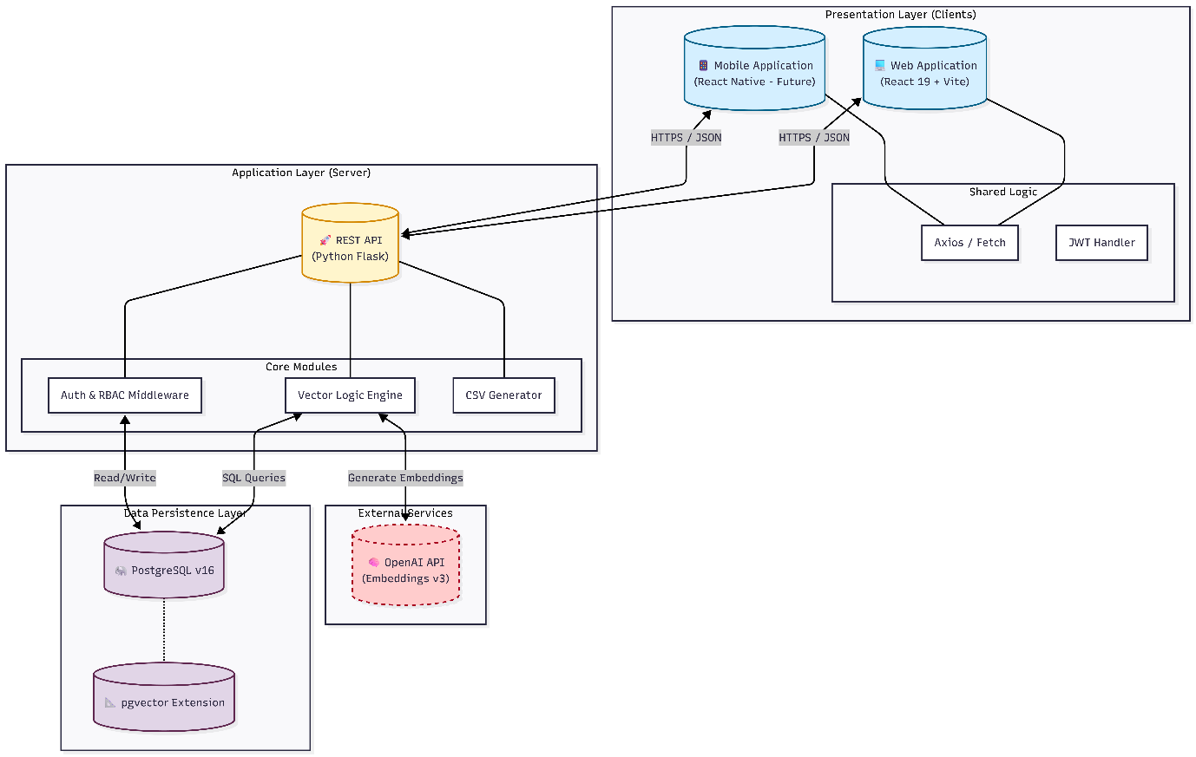

1.2 External Integrations
- OpenAI API: The system will use the text-embedding-3-small model to process text descriptions. When a new product is added, its description is sent to this API to create "vector embeddings" (mathematical representations of the text). These embeddings are then stored locally in our database. This approach ensures that future searches are fast and cost-effective, as the system does not need to call the external API repeatedly

2. System Logic & Data Flow

2.1 Data Life-Cycle
The system logic is driven by three distinct data phases: Ingestion, Construction, and Execution.
- Ingestion Pipeline (Dual-Vector Generation): When a Dietitian saves a product, the backend processes the input concurrently. It calculates a Nutritional Vector (normalized array of macro-nutrients) for mathematical comparison and sends the text description to OpenAI to generate a Semantic Embedding (1536-dimensional vector). Both are stored in PostgreSQL within a single transaction.
- Meal Construction Engine: While planning a meal, the system automatically checks every item against the selected constraints and food texture (IDDSI) in real-time. Simultaneously, it calculates the total nutritional values and updates the display instantly. This ensures that every meal built by the Dietitian is both safe and nutritionally accurate before it is approved.
- Execution & Reporting: Once a meal is saved, the system creates a permanent "snapshot" of all safety rules used at that moment for future tracking. This data is then sent directly to the kitchen dashboard in a clear, easy-to-read format. This ensures that kitchen workers see exactly what to prepare without any risk of the data being changed.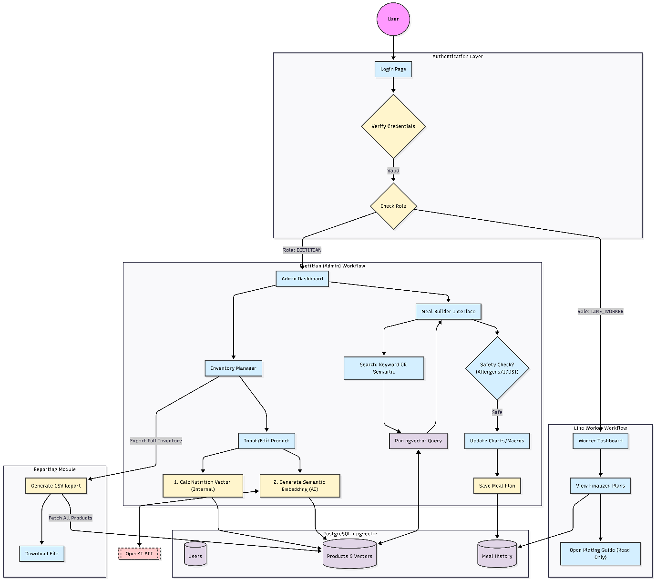

2.2 Data Interaction Flow
The following diagram illustrates the specific movement of data between the User, the Intelligence Engines, and the Database storage.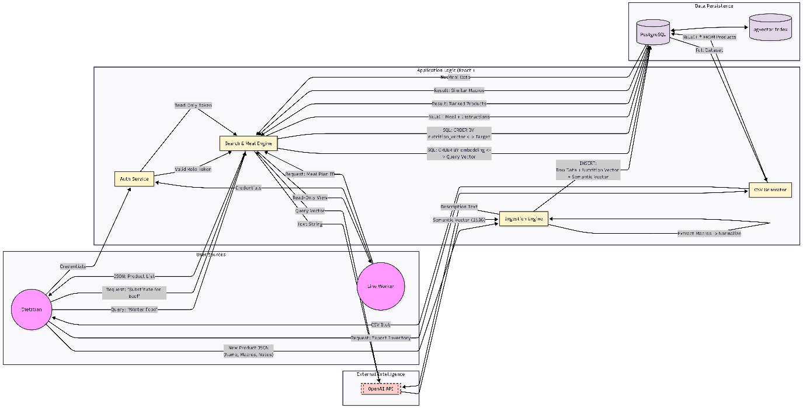

3. Database Design

3.1 Core Schema Definitions
The database utilizes a normalized relational schema integrated with vector storage.
- Users Table: This table manages system access by assigning specific roles to each user. Dietitians are granted full control to create and manage all data (Full CRUD), while Line Workers have "Read-Only" access to ensure they can view meal instructions without changing any information.
- Products Table: Acts as the central list for all food items. Beyond basic details like names and textures (IDDSI), it includes:
  - nutrition_vector: A manually calculated, normalized array of macro-nutrients used for the “Substitute Finder” algorithm.
  - semantic_embedding: A 1536-dimensional vector generated via external AI used for the “Natural Language Search” feature.
- Safety Tables (Allergens): A dedicated area to prevent mistakes. It tracks whether a product "Contains" or "May Contain" an allergen, allowing the system to enforce strict safety rules.
- Meal History (Header & Detail):
  - Meals (Header): Stores metadata (User, Date) and the constraints_snapshot. This snapshot records the safety rules active at creation time.
  - Meal Items (Detail): Links products to the header with a specific quantity multiplier, allowing for precise nutritional calculation.

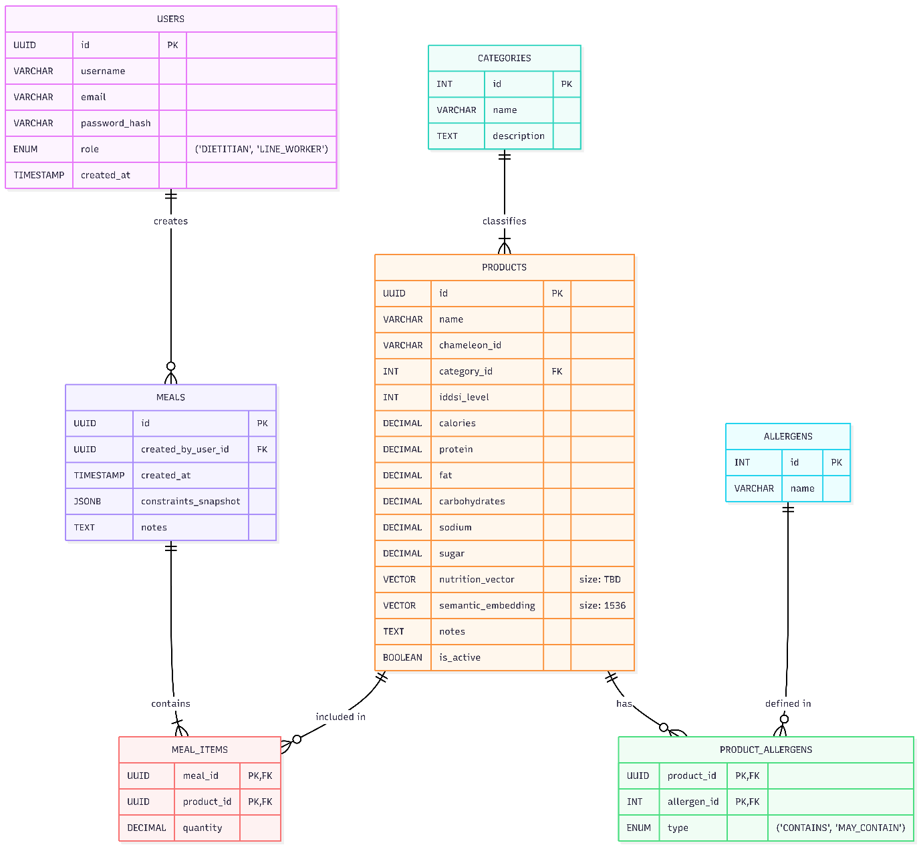

4. Algorithmic Specifications

4.1 Semantic Vector Search (Cosine Similarity)
To enable conceptual discovery (searching with natural language), the system utilizes Cosine Similarity rather than standard SQL keyword matching. User queries are converted into high-dimensional vectors and compared against stored product embeddings. The system calculates the angular distance between vectors; a value closer to 1.0 indicates a high degree of semantic similarity. This allows the search engine to understand context and intent beyond literal text matches.

4.2 Nutritional Proximity (k-Nearest Neighbors)
The “Smart Substitute” feature employs a k-Nearest Neighbors (k-NN) algorithm to identify products with equivalent nutritional profiles. When a target product is selected, the system scans the nutrition_vector space using Euclidean Distance to identify the $k$ closest data points. This ensures that suggested substitutes are mathematically close to the original item in terms of protein, fat, and caloric content.

4.3 Nutritional Clustering (K-Means)
To help the menu planning process grouping products, the system employs K-Means Clustering to categorize inventory based on nutritional density rather than arbitrary food categories. The algorithm analyzes the nutrition_vector of the entire database, iteratively grouping products into distinct clusters based on their proximity to calculated centroids in the multi-dimensional space. This automatically segments the inventory into meaningful nutritional groups such as "High-Protein/Low-Fat" or "Calorie-Dense" allowing Dietitians to discover suitable items for specific dietary protocols without manual tagging.

5. API Interface Specifications

5.1 Internal Routes (Client to Server)
Authentication Module
- POST /api/auth/login: Verifies credentials and issues a JWT session token containing the user role.
Inventory Management (Dietitian Only)
- GET /api/products: Retrieves the inventory.
- POST /api/products: Triggers the ingestion pipeline, calculating local vectors and requesting external embeddings before saving.
- PUT /api/products/:id: Updates product data and triggers vector re-calculation if necessary.
Intelligence & Search
- GET /api/search/semantic: Accepts a query string (?q=...) to perform vector-based conceptual search.
- GET /api/search/substitute/:id: Triggers the k-NN algorithm to find nutritional matches for a specific product ID.
Meal Planning
- POST /api/meals: Commits a meal plan to the database, including the safety constraint snapshot.
- GET /api/meals/:id: Retrieves full plating details (ingredients and instructions) for the Kitchen View.
Reporting
- GET /api/reports/inventory: Generates and streams a CSV export of the current database state.

6. User Interface Design

6.1 Dietitian Views (Admin)
- Inventory Dashboard: A clear, organized view where Dietitians can manage the food database. It includes an easy-to-use entry form for adding products and descriptive notes, which the system uses to power its smart search features.
- The Meal Builder: The main workspace, divided into two sections for better focus:
  - Product Discovery (Left): Features a smart search bar and a filtered list. Items that do not meet the patient's safety requirements are automatically dimmed or disabled to prevent mistakes.
  - Analysis Pane (Right): Provides instant feedback using simple charts (Pie Charts) to show calorie and nutrient distribution. It also includes a safety toolbar to easily check and toggle different dietary rules.

6.2 Line Worker Views (Read-Only)
- Worker Dashboard: A simplified, high-contrast touch interface designed for tablets. It displays a read-only list of scheduled meals, stripping away administrative controls.
- Plating Guide: A clear, receipt-style window that displays only the essential details: color-coded IDDSI levels (food consistency) and simple plating instructions.

